**PRACTICAL NO 2**

**AIM :** Create a simple SOAP Service

**SOLUTION:**

**Step 1 :** Download Intellij IDEA and JDK 8

**Step 2 :** Create a new project in Intellij Idea and select the build system as Maven

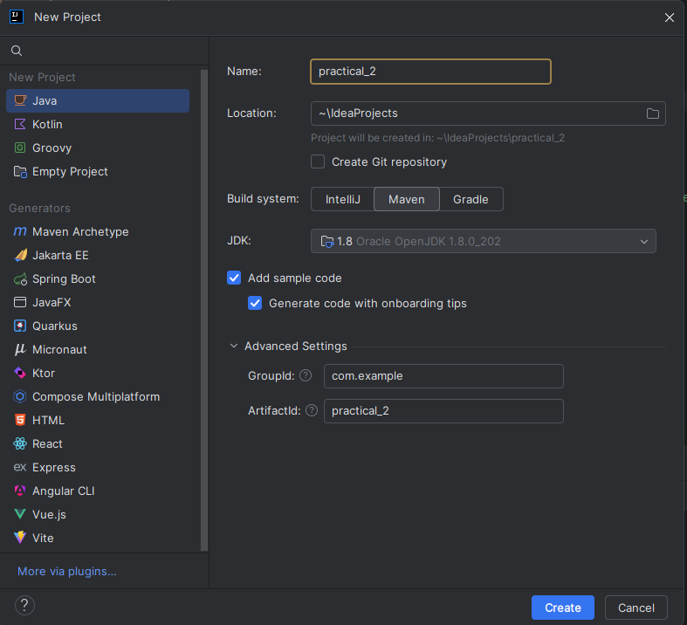

**Step 3 :** Right click on the soap folder >New> Java Class and give a name to your file . Create the below given Files

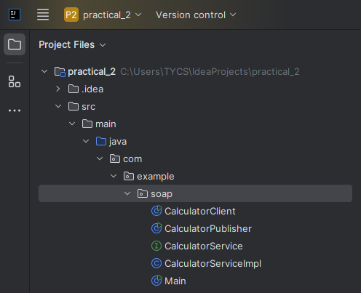

**Step 4 :** Write the code in the given files

**CalculatorClient.java**

package com.example.soap;  
  
import javax.xml.namespace.QName;  
import javax.xml.ws.Service;  
import java.net.URL;  
  
public class CalculatorClient {  
  
 public static void main(String[] args) throws Exception {  
 // URL to the WSDL  
 URL url = new URL("http://localhost:8080/calculator?wsdl");  
  
 // Correct QName based on the WSDL (Check the actual service name)  
 QName qname = new QName("http://soap.example.com/", "CalculatorServiceImplService");  
  
 // Creating service instance  
 Service service = Service.*create*(url, qname);  
  
 // Getting the port and invoking the method  
 CalculatorService calculator = service.getPort(CalculatorService.class);  
  
 int result = calculator.add(10, 20);  
 System.*out*.println("Result: " + result);  
 }  
}

**CalculatorPublisher.java**

package com.example.soap;  
  
import javax.xml.ws.Endpoint;  
  
public class CalculatorPublisher {  
 public static void main(String[] args) {  
 // Publishing the service at a specific URL  
 Endpoint.*publish*("http://localhost:8080/calculator", new CalculatorServiceImpl());  
 System.*out*.println("Service is running at http://localhost:8080/calculator");  
 }  
}

**CalculatorService.java**

package com.example.soap;  
  
import javax.jws.WebService;  
  
@WebService  
public interface CalculatorService {  
 public int add(int num1, int num2);  
}

**CalculatorServiceImpl.java**

package com.example.soap;  
  
import javax.jws.WebService;  
  
@WebService(endpointInterface = "com.example.soap.CalculatorService")  
public class CalculatorServiceImpl implements CalculatorService {  
  
 @Override  
 public int add(int num1, int num2) {  
 return num1 + num2;  
 }  
}

**Step 5 :** First run the CalculatorePublisher.java file by clicking on the run button

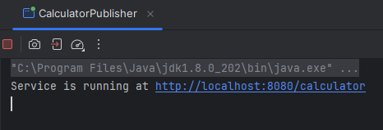

**Step 6 :** Then Run the CalculatorClient.java file

